Professional Engineering Institutions, Employers and Engineering Council (EngC) Recognised Apprenticeships – Indicators of Successful Partnerships.

The purpose of this guidance is to:

- Help Professional Engineering Institutions (PEIs) understand the role of employers in the delivery of Apprenticeships whether that is a framework or standard.
- Provide supporting information to support PEIs when developing and supporting their relationships with employers as regards apprenticeships.
- Show the factors critical to the successful delivery of apprenticeships leading to professional registration.

This guidance should be read in conjunction with the formal guidance on apprenticeship delivery and funding published by relevant government agencies, including:

Education and Training Foundation: Working Effectively with Employers
Working effectively with employers - A checklist and guide for apprenticeship providers

Apprenticeships.gov.uk :Your Responsibilities as an Employer
Your responsibilities as an employer

Department for Education: Apprenticeship Funding Rules
Apprenticeship funding rules 2024 to 2025
Apprenticeship funding rules 2025 to 2026

At a Glance

- There are positive benefits from apprentices getting involved with Professional Engineering Institution (PEI) membership from the start of their programme.

- Apprenticeships work best when there is a productive partnership with all key parties (apprentices/employer/training provider/college/university/mentor/assessor/ line manager, etc).

- Employers, as individuals or through their professional body, can shape the content (Knowledge, Skills and Behaviours) delivered in an Apprenticeship.

- Effective and productive employer involvement in assessment processes at all stages from start to end is a key component of a successful apprenticeship. Where possible, this should involve a PEI in linking this assessment to professional registration requirements.

- Some apprenticeships include a separate qualification which might be integrated into the apprenticeship. The current Funding Rules should always be considered.

- Employers should, where available, choose apprenticeships which have been recognised as having the knowledge and skills needed for professional registration.

- Employers should encourage and support apprentices to achieve professional registration.

Professional Engineering Institution (PEI) Engagements in Apprenticeship Delivery and Progression to Professional Registration – Critical Success Factors

PEI is part of the apprenticeship development group ensuring that the knowledge, skills and competence needed for professional registration are included in the Apprenticeship Standard
Engage with partners to support delivery and to encourage PEI membership.
m

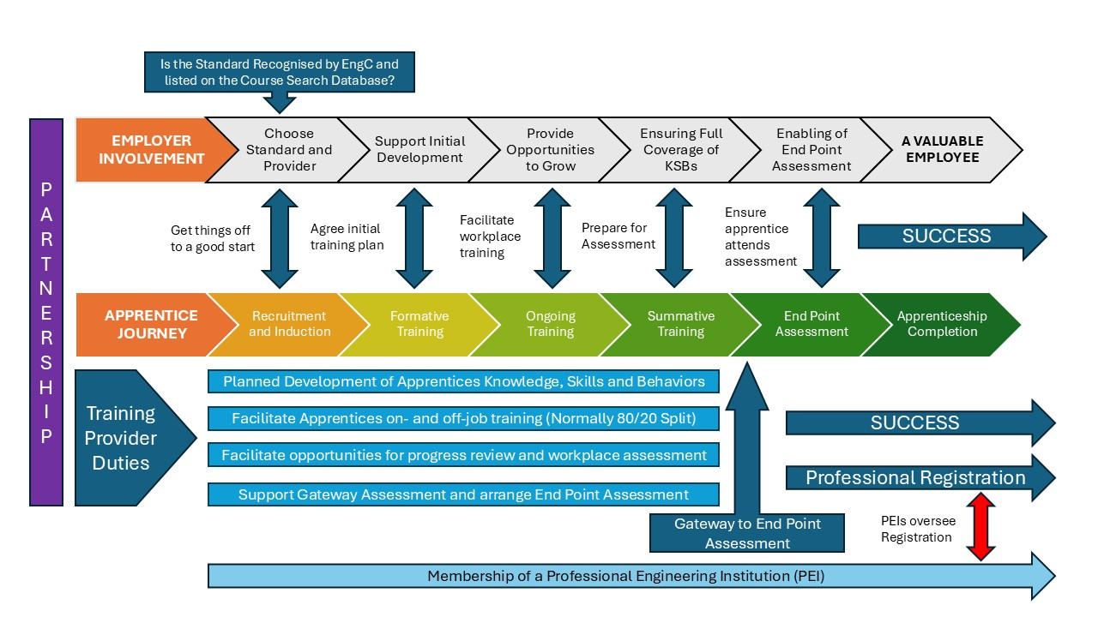
PEI use of the AAQA Standard to recognise the apprenticeship and ensure it is listed on the Engineering Council database of recognised apprenticeships.

PEI Members and Professional Engineers engage in providing training, mentoring, development.
Frequent and appropriate engagement with the Training Provider to engage with and support Apprentices.

PEI engagement (where appropriate and possible) with End Point Assessment (If applicable) and the use of this to support professional registration. This may include providing assessors and formal recognition of the EPA.

Detailed Information
Employer Involvement in Apprenticeship Delivery and Progression to Professional Registration – Critical Success Factors

The key is employer partnership with the apprentice at the centre.
m
Managing commercial pressures to enable the apprentice to attend the EPA.
Ensuring the work-place development is well planned and sequential.
Selecting a PEI recognised apprenticeship.

Engagement with a PEI to facilitate professional registration

Employer involvement with reviewing progress and contributing to assessment
Frequent and appropriate engagement with Training Provider liaison/control.

Putting the apprentice forward for EPA (If applicable) only when they are ready.

Releasing the Apprentice for at least 20%off-job training.

PEIs are advised to read pages 13 to 17 of the AAQA Guidance Note which is available for download at:

https://www.engc.org.uk/media/3743/aaqa-guidance-note-version-1.pdf

PEIs and employers should note the Department for Education Apprenticeship Funding Rules and the employer obligations these highlight

Apprenticeship funding rules 2024 to 2025

Productive Partnerships are Vital to effective Apprenticeship Delivery

- This needs to be from the outset and the role of the Professional Engineering institution (PEI) should seek to include, where practical, the following aspects:
  - Effective mapping of the Apprenticeship Standard (and the Knowledge, Skills and Behaviours it delivers) to the knowledge, skills and competences set out in the EngC AAQA Standard and UK-SPEC.
  - Provision of PEI membership support to apprentices, for example, CPD opportunities, mentoring, initial guidance and support for subsequent professional registration.
  - Provision of PEI support to Training providers such as involvement from PEI members and professionally registered engineers to support CPD, training, assessment and mentoring.
  - Supporting employers through CPD and other opportunities to enhance understanding of professional registration standards.

- The role of employers in the delivery of an apprenticeship is key to its success and where employers are insufficiently engaged there is a higher likelihood of the apprentices not completing their apprenticeship. To this end, employers should consider the extent to which they engage with the following:
  - Initial recruitment and information, advice and guidance so that the apprentice is well suited to the needs of the employer with appropriate support put into place from the outset.
  - Ensuring that the on-the-job training delivered on a day-to-day basis through routine work activities is linked to and builds on the training which takes place off-the-job at the college, training provider or university. These should be well integrated.
  - Ensure that apprentices are given the opportunity to participate in off-the-job training sessions despite the commercial pressures which may stand in the way.
  - Engage in progress reviews which involve the apprentice, the college, training provider or university and ensure that the agreed actions and targets are properly facilitated and met.
  - Appreciate that an apprentice at the start of their career will need an investment of time and support if they are to progress.
  - Engage in assessment by making opportunities available and where appropriate, providing assessment evidence such as testimonies, reports and physical examples.

Shaping the Design of an Apprenticeship and Choice

- Opportunities exist for employers (as individuals, or though their trade association or PEI) to engage with the design of apprenticeships. This makes sure that these apprenticeships meet employers’ immediate and near future skills needs as well as ensuring that the contents fully meet the knowledge, skills and competence requirements as set out in the AAQA Standard and UK-SPEC. Employers will be able to access more information on this by accessing the information provided by the various governmental bodies who deal with skills and training.

- Employers have choice when it comes to selecting apprenticeships together with the colleges, training providers and universities who deliver them. This choice will be based on a range of factors such as geography, previous experience, and local availability. It is acknowledged that with some highly specialised provision, choice may be limited.

- Those apprenticeships that have been recognised against the EngC AAQA Standard are listed on the EngC Course Search Database and employers should use this information as an indicator of quality.

Employer Involvement in Assessment (On - Programme and End - Point)

- Employers’ primary role is to facilitate the development of the apprentice and their readiness for assessment. This means that the employer will work with the Training Provider and the Apprentice in a tripartite relationship to drive forward achievement.

- Employers should make themselves familiar with the EPA assessment methods from the very start of the apprenticeship and work back from a target date to set realistic and measurable goals for the apprentice to achieve on their way towards the EPA.

- Employers should engage in the apprenticeship assessment process and ensure that all possible barriers to successful achievement are removed.

- In England, when the apprentice completes the initial practical period of their apprenticeship they will be at a point where they will be subject to a Gateway Assessment. This attests their readiness for EPA which is a summative review including a variety of assessment methods. On-programme assessment up to the point of EPA will include input from the employers and it is essential that they contribute as needed and as part of the productive partnership.

- If the apprentice does not engage with the EPA this will count as a non-achievement. Employers should ensure the apprentice is prepared for this final assessment.

- In some cases, the EPA may involve a Professional Engineering Institution (PEI) and may be used for assessment towards professional registration.

- Employers should understand that towards the end of the apprenticeship, the apprentice is likely to be working at a level where they have higher levels of responsibility and that these increased work pressures may stand in the way of the apprentice’s participation in the EPA. This should be avoided.

- All apprentices should have a higher level of responsibility as they need it to gain the KSBs and for the experiences to write about and present on during their EPAs. Pressure arises from poor planning and pushing the apprentices to pass their Gateway Assessment and sit their EPA before they are ready. Apprentice’s wellbeing and mental health should be at the forefront at all stages and especially during the run up to the Gateway Assessment and the EPA.

- Employers should not allow themselves to be pressurised for early assessment before the apprentice is fully prepared.

Where there is a Separate Qualification

- Some apprenticeships have been designed to include a separate qualification. Sometimes this is integrated and sometimes it is stand alone.

- The rules for this situation are made clear in the apprenticeship and associated assessment plan.

- It is easy to view this qualification as the main outcome but employers should avoid viewing it in that way. Achieving this qualification is not the same as achieving the overall apprenticeship. Non-achievement of the overall apprenticeship impacts on funding and leads to a financial loss as well as risking Training Provider ratings and ongoing government support for the apprenticeship.

- In some cases, employers and apprentices have viewed the separate qualification and the EPA when that is not the case.

- Employers should have productive partnerships with the chosen training provider/college/university to ensure they fully understand how the separate qualification fits in.

Advice on Choosing an EngC Recognised Apprenticeship

- Employers should understand that there is scope for Professional Engineering Institutions to use the Approval and Accreditation of Qualifications and Apprenticeships (AAQA) Standard to evaluate an apprenticeship in terms of whether it delivers the Learning Outcomes and/or Competences required for professional registration and that the assessment arrangements are sufficiently robust with an appropriate assurance of the quality of delivery staff, physical resources and support mechanism.
- Employers should note that where an apprenticeship (or qualification) has been subject to the AAQA process, and it has been confirmed that it meets the AAQA Standard, it will be listed on the Engineering Council database of approved/accredited qualifications and apprenticeships. Employers should acknowledge that not all apprenticeships are recognised against the AAQA Standard

- This listing permits a more efficient route to professional registration as the apprenticeship (or qualification) has been confirmed as meeting the relevant standards. This is dependent upon recognition being applicable to the relevant Assessment Organisation or delivery provider.

- Employers could engage with Professional Engineering Institutions to be part of the approval/accreditation process if that is identified as being valuable and appropriate to the process.

- Employers should note that not all apprenticeships will have been subjected to the approval/accreditation process and that this is for a range of reasons which are not necessarily negative but might be down to the fact that a programme has not yet been considered for approval/accreditation. Those apprenticeships where there is a strong relationship between the Professional Engineering Institution and other stakeholders are more likely to have been approved/accredited.

Apprentice involvement with Professional Engineering Institutions

- Membership of a Professional Engineering Institution from an early stage should be encouraged. It offers many benefits including access to CPD, resources, staff development, awards, community, latest thinking, etc and adds real business value.

- Many employers value the opportunities for their apprentices (and employees) to engage with a relevant Professional Engineering Institution and to gain professional registration with a title of Engineering Technician (EngTech), Incorporated Engineer (IEng), Chartered Engineer (CEng) or Information and Communications Technology Technician (ICTTech).

- Employers should understand the value proposition for professional registration for the apprentices and employees. This is wide ranging and includes:
  - Recognition that an agreed national standard has been reached.
  - A positive statement to customers that staff are well qualified and display appropriate professional standards.
  - That apprentices and employees are maintaining their skills, expertise, standard, and ethical principle through ongoing continuing professional development.
  - Professional registration may be part of a personal development scheme, may be used as part of the remuneration package, and may aid staff recruitment and retention.

