Apprentice Road Map to Professional Registration

At a Glance

- When an apprentice completes their apprenticeship they may be eligible to apply to become a professionally registered engineer.

- Professional registration is available at three levels, namely Engineering Technician, Incorporated Engineer and Chartered Engineer. These align with apprenticeships at Levels 3, 6 and 7 respectively.

- The professional registration process is managed by a Professional Engineering Institution(PEI) who operate on behalf of the Engineering Council.

- Sometimes, the apprenticeship will have been reviewed by a PEI against the Engineering Council AAQA Standard to see if it demonstrates the knowledge and understanding and/or competence required for professional registration.

- The PEI will conduct a professional review to confirm.

- Even if the apprenticeship has not been reviewed and recognised, an application for professional registration can still be made.

- It is important to talk to a PEI to reach an understanding as to what is required.

The diagram below shows how a productive partnership between the apprentice, employer, training provider and the professional engineering institution is vital at all stages.
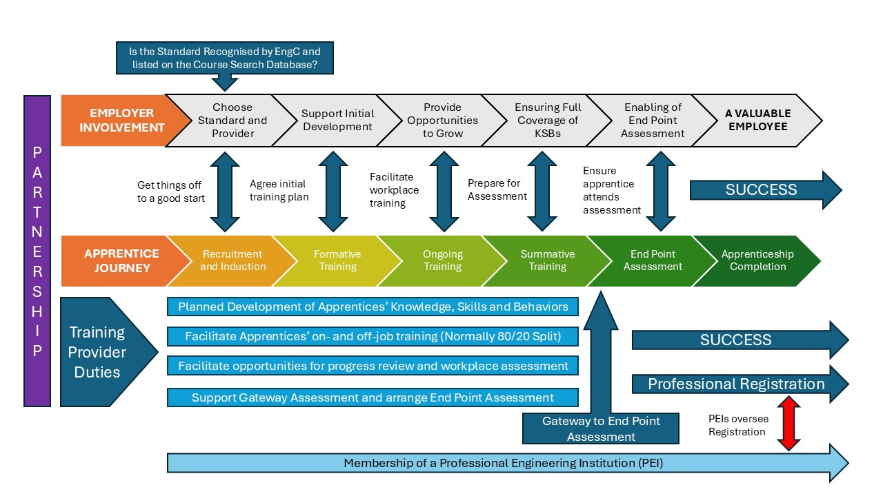

Professional Registration takes place at this point

Detailed guidance on becoming professionally registered

STEP 1: Join a Professional Engineering Institution (PEI)

Find a PEI and start your professional registration journey as early as you can. Many PEI’s offer apprentice or student membership which will give you access to the full spectrum of membership services and benefits whilst working towards professional registration. You’ll have access to valuable resources and Continuing Professional Development (CPD) to support your professional growth. If you can’t decide which PEI then join more than one.

Here you can find a list of PEIs

Congratulations! You have completed your Apprenticeship
Now it’s time to become registered as a Professional Engineer

The Professional Registration title you can apply for will depend on the level of your apprenticeship, typically:

- Engineering Technician (EngTech) is Level 3 and 4
- Incorporated Engineer (IEng) is Level 6 (Bachelors Level)
- Chartered Engineer (CEng) is Level 7 (Masters Level)

Your Professional Registration assessment will be carried out by a PEI that is licensed to do this by the Engineering Council.

Things to know before you start

- Many employers encourage Professional Registration – talk to your employer first
- Professional Registration is a separate application process to your apprenticeship assessment and completion
- There is an annual PEI membership and Professional Registration fee
- Some employers support by paying the fees for professional memberships
- Achieving Professional Registration takes commitment

STEP 2: Is your Apprenticeship recognised?

There are two routes to Professional Registration and the recognition status of your apprenticeship will determine which application route you should complete.

Some apprenticeships have been recognised through a process called Approval or Accreditation. These processes look at the Learning Outcomes (LOs) and Competences delivered by the apprenticeship; and how these are supported and assessed. Full recognition will be given if the apprenticeship delivers the LOs and/or Competences and meets the standards needed for professional registration.

If your apprenticeship meets the standards, it will be listed on the Engineering Council’s Recognised Course Search database and will include the year you started your apprenticeship and the name of the Assessment Organisation and/or provider responsible for delivery and assessment. You should note that some apprenticeships include an embedded qualification and, in some cases, it is this element of your apprenticeship that will be recognised.

There are many reasons why an apprenticeship or qualification may not be recognised, and this should not be viewed as a barrier. There is a route to professional registration for those with or without a recognised apprenticeship or qualification.

Your next course of action should be to contact a PEI to receive advice and guidance on your personal application route.

Individual Route

Your apprenticeship or qualification is not recognised and is not listed on the Engineering Council Recognised Course Search database

You will be required to make an application which details the apprenticeship (and other qualifications) you have completed and demonstrate:

- The various knowledge and skills you have developed
- The competence you have developed over the duration of your apprenticeship
- Other relevant information such as experience and your continuing professional development (CPD)

Your PEI will advise which application and evidence forms you will need to complete.
Mentoring support may also be offered.

Standard Route

Your apprenticeship or qualification is recognised and listed on the Engineering Council Recognised Course Search database

This means you will be able to use your apprenticeship or qualification as evidence for some or all the requirements for professional registration depending on which elements have been recognised.

This may vary as follows:

- The knowledge element only
- The competence element only
- The knowledge and competence elements in full

Your PEI will advise which application forms you will need to complete.

STEP 3: Your Professional Review of competence and commitment

Your PEI will confirm they have received your application documents and have everything they need to start the Professional Review assessment process.

Your application will be assessed against the UK Standard for Professional Engineering Competence and Commitment (UK-SPEC) which explains the requirements you must demonstrate. In addition, PEI’s may have other requirements which relate to their particular engineering discipline. An expert review panel, consisting of registered engineers from the PEI will review your portfolio of evidence against these requirements.

Where appropriate, this is followed by a Professional Review Interview (PRI) if you are applying for IEng or CEng. Normally, EngTech applicants are not required to have a PRI, although this may be requested by a PEI if considered necessary.

In some circumstances the PRI will be combined with the Apprenticeship End Point Assessment but you should note that this is the exception and will only take place where appropriate arrangements have been put in place.

The review panel will make a recommendation on whether you meet the requirements for the professional registration title you have applied for, and a final decision will be made.

STEP 4: Your Professional Registration Application is Complete!

Your PEI will notify you of the outcome of your application and confirm next steps.

They will also confirm your post-nominals and the registration titles you can start to use:
EngTech, ICTTech, IEng or CEng

Remember, to retain your registration title you must:

- Continue to renew your PEI membership and EngC registration fee
- Maintain and develop your professional competence through CPD and keep records
- Observe, understand and abide by your PEI’s Code of Professional Conduct

If you are considering progressing to another professional registration title or membership grade contact your PEI for further support and guidance.

