Application of the AAQA Standard to use all assessment opportunities in the delivery of an Apprenticeship

Make sure that the workplace training and assessment sufficiently develops knowledge and competence.
Use the outcome of End Point Assessment as evidence of knowledge and competence.
Initial recognition of the apprenticeship through approval against the AAQA Standard

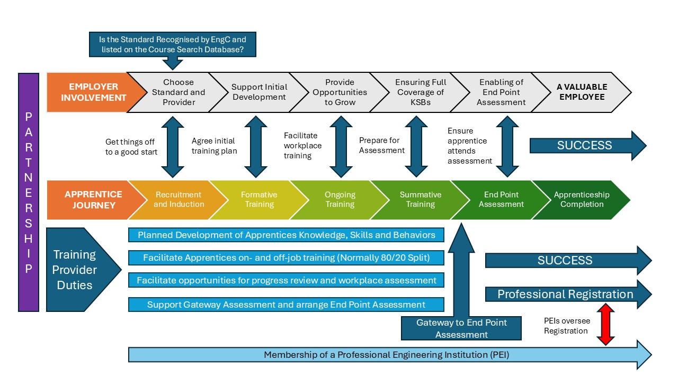
Use the outcome (Portfolio of Evidence) of on-programme assessment to demonstrate knowledge and competence.
If part of the assessment plan link EPA to PRI.
Use the Gateway Assessment (portfolio, observations, etc) as part of the evidence of knowledge and competence.
Plan Assessment and ensure this is used as part of the lead up to the Gateway to prove knowledge, competence and behaviors.
Engage with all partners as needed.

